**"COMPARATIVE ECONOMIC AND PRODUCTIVITY ANALYSIS OF CROP ESTABLISHMENT IN MECHANIZED WHEAT PRODUCTION"**

**Rojeena Dhoju (PUR075BAG028)**

**Samir Tiwari (PUR075BAG030)**

**Satish Acharya (PUR075BAG035)**



**DEPARTMENT OF AGRICULTURAL ENGINEERING**

**PURWANCHAL CAMPUS, INSTITUTE OF ENGINEERING**

**TRIBHUVAN UNIVERSITY**

**DHARAN, SUNSARI, NEPAL**

**MAY, 2023**

**COMPARATIVE ECONOMIC AND PRODUCTIVITY ANALYSIS OF CROP ESTABLISHMENT IN MECHANIZED WHEAT PRODUCTION**

**PROJECT REPORT SUBMITTED TO THE DEPARTMENT OF AGRICULTURAL ENGINEERING IN PARTIAL FULFILLMENT OF THE REQUIREMENTS FOR THE DEGREE OF BACHELOR OF ENGINEERING IN AGRICULTURAL ENGINEERING**

**By:**

**Rojeena Dhoju (PUR075BAG028)**

**Samir Tiwari (PUR075BAG030)**

**Satish Acharya (PUR075BAG035)**

***Under the guidance of***

**Asst. Prof. Yam Kumar Rai**



**DEPARTMENT OF AGRICULTURAL ENGINEERING**

**PURWANCHAL CAMPUS, INSTITUTE OF ENGINEERING**

**TRIBHUVAN UNIVERSITY**

**DHARAN, SUNSARI, NEPAL**

**May, 2023**

# CERTIFICATE

This is to certify that the project entitled**, "COMPARATIVE ECONOMIC AND PRODUCTIVITY ANALYSIS OF CROP ESTABLISHMENT IN MECHANIZED WHEAT PRODUCTION"** by **Rojeena Dhoju (PUR075BAG028), Samir Tiwari (PUR075BAG030) and Satish Acharya (PUR075BAG035)** presented toward the partial fulfillment of the requirement of **Bachelor of Engineering (B. E.) degree in Agricultural Engineering** has been completed under my supervision. I recommend the same for acceptance by Tribhuvan University, Institute of Engineering.

…….................................. ……..................................

**Date Asst. Prof. Yam Kumar Rai**

(Project Supervisor)

# CERTIFICATE

The project report entitled, **“COMPARATIVE ECONOMIC AND PRODUCTIVITY ANALYSIS OF CROP ESTABLISHMENT IN MECHANIZED WHEAT PRODUCTION** by **Rojeena Dhoju(PUR075BAG028)** and **Samir Tiwari (PUR075BAG030) and Satish Acharya(PUR075BAG035)** presented toward the partial fulfillment of the requirement of **Bachelor of Engineering (B.E.) degree in Agricultural Engineering** has been examined by us and is accepted for the forward of Bachelor of Engineering (B.E.) degree in Agricultural Engineering at Tribhuvan University, Institute of Engineering, Purwanchal Campus, Dharan.

|  |  |  |  |
| --- | --- | --- | --- |
| **1** | **Asst. Prof. Yam Kumar Rai** | | ........................................ |
|  | (Project Supervisor) | | Date: |
|  |  | |  |
| **2** | **Er. Md Shamshad Ansari** | | ........................................ |
|  | (External examiner, Scientists, S2) | | Date: |
|  |  |
| **3** | **Asst. Prof. Aditya Dhakal** | | ........................................ |
|  | (Head of Department) | | Date: |
|  |  | |  |
| **4** | **Asst. Prof. Om Prakash Dhakal** | | ........................................ |
|  | (Campus Chief) | | Date: |

# COPYRIGHT

The author has agreed that the library, Department of Agricultural Engineering, Purwanchal Campus, Institute of Engineering may make this report freely available for inspection. Moreover, the author has agreed that permission for extensive copying of this project report for scholarly purposes may be granted by the supervisor who supervised the project work recorded here in or, in their absence, by Head of the Department wherein the project was done. It is understood that the recognition will be given to the author of this report and to the Department of Agricultural Engineering, Purwanchal Campus, Institute of Engineering or in any use of the material of this project report. Copying or publication or the other use of this report for financial gain without approval of to the Department of Agricultural Engineering, Purwanchal Campus, Institute of Engineering and author's written permission is prohibited.

Request for permission to copy or to make any other use of the material in this report in whole or in part should be addressed to:

……………………………..

Head of the department

Department of Agricultural Engineering

Purwanchal Campus, Institute of Engineering

Tribhuvan University

Dharan Sub-metropolitan, Ward No. 8

Sunsari District, Koshi Province, Nepal

# ABSTRACT

The mechanization of wheat farming in Nepal today has increased, making it an important component of the agricultural industry. Since the majority of farmers in Nepal still use conventional farming techniques, mechanization in wheat production is still in its infancy. But in recent years, the Nepal government has pushed for the adoption of cutting-edge agricultural technologies, such as farm mechanization, to boost the yield of wheat and other crops. The national productivity for wheat crop in Nepal is 2.99 MT/ha, with 711,067 hectares under cultivation (statistical information, 2020/21). The formation of the Nepal Agricultural Research Council played a significant role in pushing up the rising trend of productivity.The main objective of this research is to examine the impact of farm mechanization on wheat productivity (mainly Super Seeder, Rotavators or Farmer’s Practice and Zero-Till Seed cum Fertilizer Drill). Compared to modern farming methods, traditional farming practices are less productive, which reduces yields and revenue. Additionally, it might not have sufficient methods for managing pests and diseases, which would lead to crop losses and lower yields. It takes a lot of manual labor, which may be physically taxing and time-consuming, and are frequently labor-intensive. In order to address these issues, in this study we undertook three plots where we employed a super seeder, rotavator and zero-till seed cum fertilizer drill for wheat seed establishment in the study field. Experiments were carried out in ten sample with three treatments in 5680 plot area. BL4341 variety of wheat seed was used to sow at the seed rate of 118.34 kg/ha. DAP, Urea and Potash fertilizer were used @ 3:2:1.5 kg per Katha and herbicides such as pendimethalin, 2-4-D and glyphosate were used @ 3.5, 1.5, 3 liters per hectare. The highest yield of 3426.9 kg/ha was obtained in treatment 1 (T1) where super seeder was used for wheat cultivation followed by farmer’s practice of kg/ha. The lowest yield of 2484.4 kg/ha was obtained where zero-till seed cum fertilizer drill was used for wheat cultivation. The yield using super seeder was 11.14% higher than the farmer's practice and cost of production was 2.78% lower than FP. The highest benefit-cost ratio was found in using super seeder of 2.44 and that of zero-till seed cum fertilizer drill and farmers practice was 1.39 and 0.2. Thus, the application of these modern mechanized agricultural machinery is found better and profitable in the study area.

**Key words**: Mechanization, Traditional Practices, Economic Analysis, Gross Margin, Benefit-Cost Ratio, Wheat Cultivation.

# ACKNOWLEDGEMENT

First and foremost, we would like to thank our project supervisor, Asst. Prof. Yam Kumar Rai and external examiner Er. Md Shamshad Ansari, Scientist from Directorate of Agricultural Research under NARC for their invaluable guidance, support, and expertise throughout the project. Their insightful suggestions, constructive feedback, and unwavering encouragement have been instrumental in shaping the direction and quality of this report. I am truly grateful for their patience, mentorship, and dedication during the course of investigation, writing and presentation of thesis.

We would like to express our sincere gratitude and respect to the Department of Agricultural Engineering, Purwanchal Campus for including the final year project as part of our syllabus for final year B.E. in Agriculture.

We are highly indebted to Technical officer Er. Manoj Joshi, and Directorate of Agricultural Research office under NARC, Tarahara team for providing us with research field, necessary support and guidance till the end to complete this project report successfully, HOD of Department of Agricultural Engineering, Assoc. Prof. Jawed Alam, Assistant Professor Govinda Neupanae for their untiring help, valuable suggestions and timely moral support, which enabled us to accomplish this task.

Lastly, we would like to acknowledge the participants of our study who generously shared their time, insights, and experiences. Without their cooperation and willingness to be part of this research, this project would not have been possible.

To all those who have directly or indirectly contributed to this project, we are grateful for your involvement and support. Your contributions have enriched our learning experience and have played an integral role in the successful completion of this report.

**Rojeena Dhoju**

**Samir Tiwari**

**Satish Acharya**

**May, 2023**

# Table of Content

CERTIFICATE ii

CERTIFICATE iii

COPYRIGHT iv

ABSTRACT v

ACKNOWLEDGEMENT vii

Table of Content viii

ACRONYMS AND ABBREVIATION xi

LIST OF TABLES xii

List of Figure xiii

Chapter 1: Introduction 1

1.1 Background: 1

1.2 Statement of problem: 4

1.3 Objective: 5

General objective: 5

Specific objective: 5

1.4 Significance of the study: 5

1.5 Scope and Limitation of Study 6

1.6 Research Question 6

Chapter 2: Literature Review 7

Chapter 3: Methodology 12

3.1 Study Area 12

3.2 Study Methodology 13

3.2.1 Plot Division 13

3.2.2. Calibration for Treatment used 14

3.2.2.1. Calibration of zero till seed cum fertilizer drill 14

3.2.2.2. Calibration of Super Seeder 15

3.2.3 Sowing of Wheat 15

3.2.4 Area of plot 16

3.3 Data collection 16

3.3.1 Primary Data 17

3.3.1.1. Area of plot 17

3.3.1.2. Seed rate of the implement 17

3.3.1.3. Volume of irrigation of water applied in the field 18

3.3.1.4. Amount and Type of Fertilizer and Herbicide applied 18

3.3.1.5. Sampling of crop plant 19

3.3.1.6. Determination of plant parameter 19

3.3.1.7. Yield Measurement 19

3.3.1.8. Thousand Grain Weight 20

3.3.1.9. Moisture Content Measurement 20

3.3.1.10. Adjusted Yield 20

3.3.1.11. Gross Margin 21

3.3.1.12. Benefit-Cost Ratio (B/C Ratio) 21

3.3.2. Secondary Data 22

3.4. Data Analysis 22

Chapter 4: Results and Discussion 23

4.1 Calibration of Treatments 23

4.1.21. Calibration of Super Seeder 23

4.1.2. Calibration of Zero-Till 24

4.2. Comparative Analysis of Treatment 24

4.2.1. Comparison of Wheat yield 25

4.2.1.1. Wheat Yield in 1 area 25

4.2.1.2. Total yield of entire field 25

4.2.1.3. Straw yield 28

4.3. Number of plants per 1 (Total Plant Population) 29

4.4. Plant Height 30

4.5. Spike length 32

4.6. Grain per spike 33

4.7. Thousand grain weight 34

4.8. Number of tillers per plant 35

4.9. Comparison of Volume of water required for irrigation 36

4.10. Moisture Content of grain 38

4.11. Straw to grain ratio 39

4.12. Adjusted yield 41

4.13. Gross Margin 41

4.14. Benefit Cost Ratio (BCR) 45

Chapter 5: Conclusion and Recommendation 46

5.1. Conclusion 46

5.2. Recommendation 47

References 48

ANNEX 49

# ACRONYMS AND ABBREVIATION

|  |  |
| --- | --- |
| ATF | Agricultural Tools Factory |
| BCR | Benefit Cost Ratio |
| CM  DAP  DoAR | Conventional Method  Di-ammonium Phosphate  Directorate office of Agricultural Research |
| FP | Farmer’s Practice |
| MC | Moisture Content |
| NARC | Nepal Agricultural Research Centre |
| SS | Super Seeder |
| ZT | Zero-Till Seed cum Fertilizer Drill |

# 

# 

# 

# 

# LIST OF TABLES

Table 3.1 Sowing of Wheat 16

Table 3.2 Area of plot 17

Table 3.3 Amount and Type of Fertilizer and Herbicide applied 19

Table 4.1 Total yield of entire field 26

Table 4.2 Straw yield per ha. 29

Table 4.3 Total Plant Population per 29

Table 4.4 Average Plant Height 30

Table 4.5 Average Spike Length 31

Table 4.6: Average Grain per spike 33

Table 4.7 Thousand grain weight 34

Table 4.8 Average Number of tillers per plant 34

Table 4.9 Comparison of Volume of water required for irrigation 37

Table 4.10: Moisture Content of grain 38

Table 4.11: Straw-to-grain ratio 39

Table 4.12 Adjusted yield 41

Table 4.13 Gross Margin 42

Table 4.14: Benefit Cost Ratio (BCR) 45

# List of Figure

Figure 1.1: Various farm mechanization development for different phase of crop production in Nepal. 3

Figure 3.1: flow-chart of the project. 13

Figure 3.2: Study area, NARC Tarahara. 14

Figure 4.1: Average Yield per m2 27

Figure 4.2: Total yield vs. plant population in Farmer’s practice field 28

Figure 4.3: Total yield vs. plant population in ZT field 28

Figure 4.4: Total yield vs. plant population in SS field 29

Figure 4.5: Average plant population per meter square 31

Figure 4.6: Average plant Height (cm) 32

Figure 4.7: Average spike Length (cm) 33

Figure 4.8: Average Grain per spike 34

Figure 4.9: Thousand Grain weight 35

Figure 4.10: Average number of tillers per plant 36

Figure 4.11: Comparison of Volume of water required for irrigation 37

Figure 4.12: Average Moisture Content of grain 40

Figure 4.13: Average Straw-to-grain ratio 41

ANNEX

Annex A: One-meter square grain weight (gm.) 49

Annex B: Number of plant per 50

Annex C: Plant Height (cm) 50

Annex D: Spike Length (cm) 50

Annex E: Number of Grain per Spike 51

Annex F: Number of tillers per plant 51

Annex G: Moisture content of grain (%) 52

Annex H: One-meter square Sample weight (gm.) 53

Annex I: Picture of Activities 54

# Chapter 1: Introduction

## 1.1 Background:

One of the basic foods of Nepal is wheat, a significant grain crop farmed around the world. The mountainous and Terai regions of Nepal have the highest concentration of wheat growing, which is a significant cash crop for local farmers. Wheat farming in Nepal has a long history that begins with the introduction of the crop by traders and visitors from nearby nations. As food consumption has increased, wheat planting has increased and has become a significant component of the Nepalese diet. Between November and April, Nepal's winter growing season, wheat is commonly cultivated there. The Terai region and middle hills regions make up the majority of Nepal's wheat-growing regions.

The Ministry of Agriculture and Livestock Development (MoALD) reports that Nepal's production of wheat climbed from 1.3 million metric tons in 2015–16 to 1.6 million metric tons in 2020–21. According to the economic survey results for 2019, Nepal produced 1786 tons of wheat, up from 265 tonnes in 1970, with an annual growth rate of 4.74% (*STATISTICAL-INFORMATION-ON-NEPALESE-AGRICULTURE-2077-78*, n.d.-a). The hilly and mountainous portions of Nepal, then the Terai region, provide the majority of the country's wheat. Jhapa (4.16 MT/ha), Bhaktapur (4.55 MT/ha), Nawalparasi east (3.60 MT/ha), Bardiya (4.37 MT/ha), Surkhet (3.38 MT/ha) and Kailali (4.03 MT/ha) are the principal wheat-growing districts from each province in Nepal (MoALD, 2020/21).

There are a number of difficulties with wheat farming in Nepal, including low productivity, and restricted access to contemporary farming methods and technologies. The distribution of high-yielding wheat varieties, instruction in contemporary farming methods for farmers, and the provision of subsidies for inputs like fertilizer and seeds are just a few of the measures the government of Nepal has done to encourage wheat cultivation and boost its productivity. The Nepal government has been enacting a number of programs and regulations. Inputs like fertilizer and seeds are subsidized, high-yielding wheat varieties are distributed, and farmers are trained in contemporary agricultural methods. In conclusion, wheat farming is a significant component of Nepali agriculture and is essential to the security of the nation's food supply. Despite the difficulties experienced by farmers, it is anticipated that government measures to promote wheat growing will enhance productivity and improve farmers' living conditions.

The agricultural industry in Nepal has a long history, and many old farming techniques are still in use. Modern agricultural machinery has, however, only recently and somewhat slowly been adopted in Nepal. Prior to the 1950s, Nepal's traditional farming practices including oxen-pulled plows and hand cultivation were standard practice. Due to the nation's isolation and restricted access to advanced technologies, the usage of agricultural machinery was nearly unattainable. Huta Ram Baidhya, Nepal's first agricultural engineer, and Mr. Siddi Nath Regmi, Nepal's second agricultural engineer, laid the groundwork for agricultural mechanization in Nepal (Shrestha Shreemat, 2022). During their service dates various agricultural tools such as metal animal-drawn mould-board plough, disk harrow, thresher, pump set, tractor-trailer, wheel-barrow, hand hoes, etc. were manufactured at Agricultural Tools Factory (ATF). Later, during the 1970s and 1980s with the assistance of international organizations various mechanized agricultural machinery were imported and brought into application in farmers' fields.

Mechanized wheat cultivation is the practice of doing numerous tasks associated with growing wheat using contemporary machines and equipment. Mechanized farming techniques have a number of benefits over conventional farming practices, including timely sowing, increased productivity, and lower labor costs. Mechanized wheat farming includes various steps, such as preparing the land for sowing, fertilizing crop fields, irrigating, controlling weeds, and harvesting the crop. Utilizing various pieces of machinery including tractors, seed drills, cultivators, sprayers, and combines harvester, each of these phases can be mechanized. This study undertakes Super seeder (SS), rotavator and zero-till seed cum fertilizer drill (ZT) machinery which are used to sow the wheat in the field of NARC, Tarahara with standing stubbles after harvesting the paddy crop.

The Super Seeder machinery concurrently sow wheat seeds, mulch paddy waste, and distribute manure to lower the expense of removing the stubble. It is simple to use and handle, also a combination of a seed planter and a rotary tiller that requires little maintenance. The Super Seeder is a single-pass method that meets the needs of contemporary farming and avoids crop residue burning. It is a state-of-the-art agricultural instrument that helps farmers to sow wheat seeds more rapidly and precisely, increasing production. Similarly, rotavator, also known as a rotary tiller, is a tractor-driven secondary tillage tool that plows farmland with a number of blades attached on a rotating shaft to cut, pulverize, mix, and level the soil. In fewer passes through the field, they create an optimal seedbed for wheat or crop sowing. Also ZT, commonly referred to as no-till farming, is a way of cultivating crops without tillage procedures like harrowing or plowing the soil. Zero tillage's guiding principle is to cause the least amount of soil disturbance possible. This helps to maintain soil structure, minimize soil erosion, and keep soil moisture in check. These mechanized cultivation practices produce an increase in productivity and reduced the cost and time of sowing. Additionally, the use of these treatments reduces the burning of crop residue that has detrimental effects on both the environment and human health.

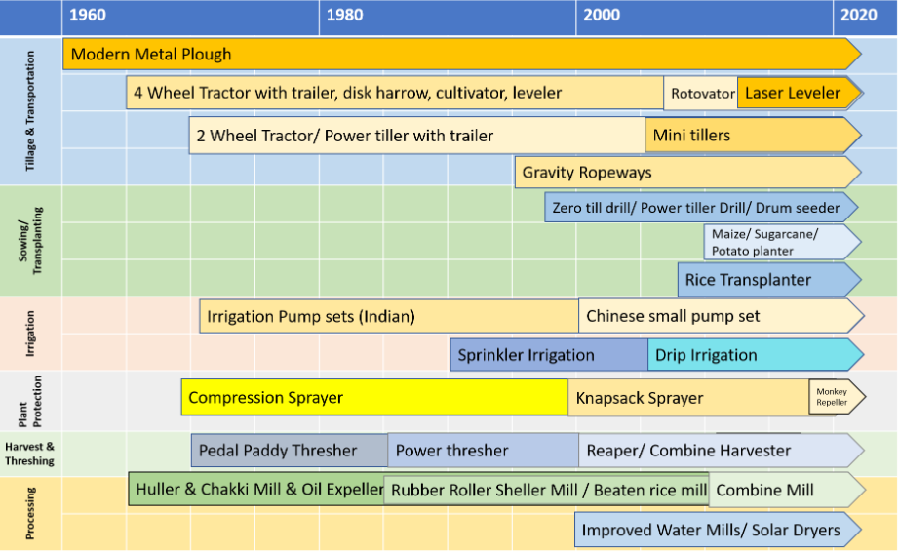

Figure 1.1: Various farm mechanization development for different phase of crop production in Nepal. (Source: Shrestha Shreemat, 2022)

## 1.2 Statement of problem:

The primary problem with traditional wheat production practice is that it is labor intensive and time consuming. Additionally, traditional practice is often less efficient and yield is lower than mechanized production. Quality seeds are the most important inputs for wheat production. Poor quality or insufficient availability of quality seeds leads to low yields and poor quality of wheat. Traditional/manual wheat production practice mostly leads to incorrect crop management such as non-uniform seed distribution, incorrect sowing depth and spacing etc. leading to poor yields and low quality of harvested wheat grain. Manually sown wheat requires adequate irrigation for good wheat yields. Lack of irrigation leads to low yields and poor quality of wheat. They are also susceptible to Pests and diseases which can cause serious damage to the crop and lead to low yields.

Also, the migration of rural youth into foreign countries is resulting in lack of labor for agricultural activities and the majority of cultivable agricultural land area is being left uncultivated. Due to these factors, agricultural output is reduced, which is contributing to national food insecurity. Use of modern farm machinery technologies in wheat production can improve the yields and quality of wheat. The use of mechanized methods allows for timely planting and harvesting, which can result in higher yields. Additionally, mechanized production can often be done with fewer workers, reducing required time and labor costs. This can make mechanized wheat production more cost-effective than manual production. In general, manual wheat sowing can be a labor-intensive and inefficient technique that can lead to non-uniform seed distribution, decreased yield, and higher production costs for farmers. These issues can be resolved and the effectiveness and sustainability of wheat production can be improved by implementing innovative technology, such as the Super Seeder, Turbo Seeder, Rotavator and Zero-Till Seed cum Fertilizer Drill etc.

## 1.3 Objective:

### General objective:

To study the impact of farm mechanization in wheat production.

### Specific objective:

* To compare the yield using different agricultural machinery.
* To perform the economic analysis of different crop establishment technology.
* To compare various plant parameters.

## 1.4 Significance of the study:

Various modern machinery has been introduced to the market in this mechanized era to make field work more productive, less time-consuming, and less expensive. Since Nepal's agricultural land is shrinking day by day causing the nation to experience food insecurity, where mechanization in wheat production operations has assumed a crucial role. A sense of importance toward mechanization in the agricultural industry has also been produced by the workforce scarcity for agricultural jobs. The desire for farm mechanization is a result of a shortage of agricultural workers and their rising daily wages. Additionally, youngsters returning from foreign industrialized nations are perceived as being more interested in and investing in their new careers in commercial agriculture, creating a significant need for mechanization in agriculture (Thapa Dhruba, 2021)

Mechanization in agriculture is essential for boosting crop production and productivity as well as the effectiveness of field labor. The use of various automated machinery during various stages of field operation helps to finish the work more quickly and affordably. Indirectly, it aids in managing the straw left over from paddy harvesting. In order to cultivate wheat, a variety of tools have been developed and made available to farmers, including the rotavator, ZT, SS, sprayer, reaper, thresher, and combine harvester. By using this equipment in farmers' fields, the labor scarcity issue and other farm-related issues are addressed, increasing overall field production and lowering cultivation costs. The use of special wheat sowing equipment, such as the SS, and ZT, makes it possible to plant wheat seeds among the standing paddy stubbles in the field, assisting farmers in resolving their straw burning issue. These techniques for sowing wheat help to increase the soil's biomass content, protecting the soil's microbial community and nutrient content. By enhancing and commercializing agriculture, mechanization also improves food security. The main purpose of this study is to comprehend the various factors that affect the yield produced when using different machinery, to conduct a comparative economic analysis of these machinery in the production of wheat, and to recommend to farmers the best machinery that produces a higher yield at a lower cost of production. According to Jha et al. in Bangladesh traditional farms produced 2.57 mt/ha less wheat than mechanized farms (2.65 mt/ha).

## 1.5 Scope and Limitation of Study

The scope of this study is to analyze the impact of mechanized agricultural machinery in the productivity and economic sector of wheat cultivation. Mechanized wheat production has revolutionized the agricultural industry, but there are still some limitations to this method of farming. Here are a few of them:

1. Soil parameters are not studied in this research such as soil moisture content, soil texture, soil fertility and bulk density.
2. Impact of groundwater and the level of the water table are also not considered in this study.

Overall, while mechanized wheat production has many advantages, it is important to recognize the limitations and consider implementing sustainable farming practices to mitigate potential negative impacts.

## 1.6 Research Question

After the completion of the study, one will be able to answer the following question regarding this study:

1. Which modern mechanized agricultural machinery is beneficial for wheat seed establishment?
2. What is Gross Margin and Benefit-Cost Ratio?
3. What is adjusted yield and why it is important?
4. How does the yield change with respect to different treatments?
5. How crop sampling is to be done?

# Chapter 2: Literature Review

According to a study, wheat was cultivated on 708,000 hectares in 2021 and yielded 218,500 metric tons, which is roughly a six-fold increase in output from the same amount of land(Samaya Gairhe et al., 2019). Wheat area, output, and productivity all showed an upward trend, but production was higher than area and productivity. The yearly consumption increased from about 13 kg in 1961 to 41 kg in 1988 and 65 kg in 2013(JIquan Peng et al., 2022) This unequivocally demonstrates the rise in wheat demand over time. In order to meet the country's needs, the Nepali government should concentrate on expanding wheat output. This can be done by implementing mechanical wheat cultivation techniques, such as the utilization of various pieces of farm equipment for tilling, sowing, and harvesting. All types of crops can be significantly improved in terms of cost, output value, income, and return rate by increasing their level of mechanization. The yields of all crops, grain crops, and cash crops improve by 1.2151, 1.5941, and 0.4351%, respectively, with every 1% increase in the level of mechanization(Rajesh Murumkar et al., 2015). Some of the reviewed literature related to this projects as as follows:

“Study the impact of different agricultural machinery uses on wheat cultivation practices at Agricultural Machinery Testing and Research Centre (AMTRC), Sarlahi, Nepal” by Jha R.N. et al. (November,2019) studied the impact of various agricultural machinery and cultivation practices in wheat crops at AMTRC. This study used a 2800 m2 plot size and five treatments with three replications each. Through the use of pooled analysis techniques, the study examined the grain yield of various treatments. According to the results of this trial, a zero-till seed drill machine provided the maximum grain production at 3659.17 kg/ha, followed by a zero-tiller rotavator at 3456.67 kg/ha. The zero-till seed drill's gross margin was also determined to be 33.67% higher than the farmer's methods.

“Impacts of agricultural mechanization: a case of Palpa district of Nepal” by Arjun Prasad Khanal (May, 2020) conducted a study to examine the impact of agricultural mechanization in Palpa district, Nepal. Farmers benefited with mechanization programs were randomly selected and data was collected through interview and analyzed using SPSS and Microsoft tools. This study found out that the majority of Palpa farmers are adopting light machinery (89.5%) and only 10.5 % farmers are adopting heavy agricultural machinery. This study also assesses the impact of agricultural mechanization on working efficiency, cost of production, productivity as well as on socio-economic living standard of farmers. Study concluded that the agricultural mechanization of Palpa was still in its childhood and yet there is tremendous possibility of transforming existing traditional and masculine agriculture into modern, commercial and mechanized agriculture. Study recommends the purchasing and distributing machines to farmers does not meet the spirit of agriculture mechanization. Agriculture mechanization was found to have positive impacts in productivity of agriculture products because the majority (89%) of the farmers experienced an increase in productivity of their agriculture products after mechanization.

Another study on, “Zero till in wheat from the gender perspective in Nepal” by Sudha Sapkota et al. (January 2021) evaluates the implementation of different tillage practices in the farmer field of Sunsari district. This paper discusses the justifications for gender inclusion in the project and the development studies. A comparison of traditional practice and zero-till wheat production revealed that the producer can save about NRs. 4000/ha during cultivation practices, but that NRs. 9842/ha can be saved from a hectare of land when the product is harvested. As a result, the Sunsari district can profit from zero-till wheat. The producer was given more authority by the introduction of zero-till because of the higher income. Although the yield advantage of ZTW was not significantly greater than that of conventional till wheat (CTW), the additional benefit of almost 34% persisted enough for the farmers to choose the zero-tillage technology. Farmers estimated that they could reduce their seed requirements by 17% and their irrigation costs by 13%.

“Present status and prospect of appropriate mechanization for wheat and maize cultivation in Bangladesh'' by Israil Hossain (August 2017) examine the planting cost, fuel saving between mechanized planting (zero till and strip till) and conventional methods. The study after 23 crops in the rotation of “wheat-mung bean-rice” with 30% crop residue retention showed that wheat, mung bean yields under strip till and no till planting were higher than conventional methods. The savings of planting cost for maize and wheat were found 77%and 44%, respectively. The net returns of maize and wheat cultivation are 1.3 times and 1.7 times compared to conventional manual planting methods. Strip till planters also avoid labor for seeding and earthing operation of maize as well as wheat seeding. There were significant planting cost differences of 4000 Tk/ha. and fuel savings differences of 66.8% between mechanized strip till planting and conventional manual method. The study also states that the fuel consumption by conventional method is 23.4 times higher than the mechanized strip till method of planting

Another “Assessment of seed cum fertilizer drill for wheat sowing after paddy harvesting” by R.P. Murumkar et al. (May 01 2023) conducted an investigation to evaluate the effectiveness of tractor-operated seed cum fertilizer drills for seeding wheat after paddy harvesting. With a seed rate of 100 kg/ha, it was discovered that the field's capacity, sowing depth, and yield were each 0.67 ha/h, 4 cm, and 12.10 q/ha, respectively, as opposed to 0.50 ha/h, no depth, and 6.13 q/ha seen when using the traditional broadcasting method. In comparison to broadcasting, the mechanized sowing method produced a 50% greater depth of sowing. (Gautam & Aulakh, 2022)

Similarly, “Impact of Sowing Technologies of Wheat Cultivation in Ferozepur, Punjab” by Anand Gautam and Gurjant Singh Aulak (May 11 2023) carried out a field experiment on the four different sowing methods ( Broadcasting +Mulcher, PAU Happy Seeder, Super Seeder, Zero Drill) on different three locations on district of Ferozepur (Punjab) during 2021-22, and found out the utmost yield was obtained in PAU Happy Seeder (54.45 q/ha) sowing methods in comparison to other three sowing method (Broadcasting + Mulcher (51.85 q/ha), Super Seeder (49.15 q/ha) and Zero Drill (45.95 q/ha), also higher B: C ratio was obtained by PAU Happy Seeder. The study also reports that the continuous application of PAU Happy Seeder will have a positive outcome on fertilizer management as it provides a healthier option for management of crop residue in the rice-wheat cropping system. This study concluded that PAU Happy Seeder can play an essential character in retaining soil and ecological fitness in Punjab. (Ali et al., 2021)

“Impact of irrigation on yield attributes of seven wheat genotypes” by Murad Ali et al. (June, 2021) carried out an evaluation of seven different wheat genotypes under different irrigation stages (I0: Control, I1: irrigation at seedling stage, I2: irrigation at seedling and booting stages, I3: irrigation at seedling, tillering and booting stages and I4: irrigation at seedling, tillering, booting and grain formation stages) in an entire crop period. This study found that the irrigation at seedling + tillering + booting stages + grain formation stages (I4) produced statistically higher yield (4277 kg/ha) and related traits while the lower was observed in control (I0). It was also observed that in case of water shortage, irrigation at seedling and booting stages reduced the drastic losses in grain yield of wheat. In full water availability, the research recommends the farmers to irrigate wheat at seedling, tillering, booting and grain formation stages for higher yield. In case of water scarcity, irrigation at seedling and booting is strongly recommended to trim down tremendous yield losses.(Sana Ullah Baloch et al., 2014)

“Effect of Different Irrigation Schedules on The Growth and Yield Performance of Wheat (Triticum AestivumL) Varieties Assessment in District Awaran (Balochistan)” by Sana Ullah Baloch et al. (May 11 2023) carried out an investigation to study the effect of different irrigation schedules on growth and yield Performance of wheat varieties. This experiment was laid out in a three replicated randomized complete block design having a net plot size of 6.0 m2. Three wheat varieties i.e., Sassui, TD-1 and Raskoh-2005 were undertaken to evaluate their performance against three irrigation schedules. The collected data were analyzed and an LSD test was applied to compare treatments' superiority. The study concluded that among irrigation schedules five irrigations produced maximum of all the growth and yield traits studied, particularly grain yield (6999.30 kg ha-1) as compared to four irrigations and 3 irrigations. Among varieties Sassui gave superior performance particularly grain yield (5818.80 kg ha-1) than TD-1 and Raskoh-2005. Hence Sassui x five irrigation interaction was found most suitable for obtaining maximum grain yield (7444.70 kg ha-1) of wheat. The results of the present study revealed that crop irrigated five times, resulted highest plant height, tillers m-2, spike length, spikelets spike-1, grains spike-1, seed index, biological yield, grain yield and the harvest index; while crop receiving 4 irrigations ranked 2nd and 3 irrigations ranked least for all the growth and grain yield traits(*Annual Report*, 2073)

According to the literature reviewed above, adoption of mechanized farming technology has been proven to increase field productivity while decreasing cost and seed required by 13% and 17%, respectively. Similar results were obtained for crop residue, which was shown to be 30% higher in wheat and mungbean yield under strip and no-till planting than conventional methods (CM), with a 1.7 times better net return in comparison to CM. Additionally, the frequency and volume of irrigation on the field have a significant impact on the wheat output. The literature cited above claims that the five irrigation interactions were determined to be the most effective for maximizing wheat grain output.

# Chapter 3: Methodology

The project will carried out in a sequence as shown in below flow-chart:

# 

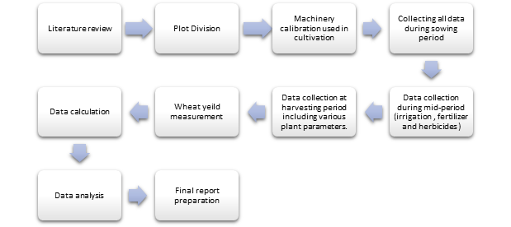

Figure 3.1: flow-chart of the project.

## 3.1 Study Area

Directorate of Agricultural Research office under Nepal Agriculture and Research Center, Tarahara is selected as the study area. DoAR is located in ward No. 2 of Itahari Municipality in Sunsari District of Province 1, the Eastern region of Nepal. Geographically the study area covers about 104 ha. and extends 26°42'09.2" North in Latitude and 87°16'34.7" East in Longitude. It is five kilometers north of Itahari Chowk lying on the eastern side of Dharan-Biratnagar highway. Tarahara has six command districts of Eastern Terai Region (ETR) of Nepal. It has a tropical zone with warm climatic conditions. Majority of the area is under irrigated condition but badly affected by present climate change and has partial irrigation. It is located at an elevation of 136 meters above sea level.

The soil texture of whole farm land is dominated by clay loam with sandy loam to loam varying with the distribution of land within the farm. The pH of the soil ranged 6.5-7.0 which indicates slight acidic to neutral status of the soil. (*Grain Moisture Meter*, n.d.)

## 

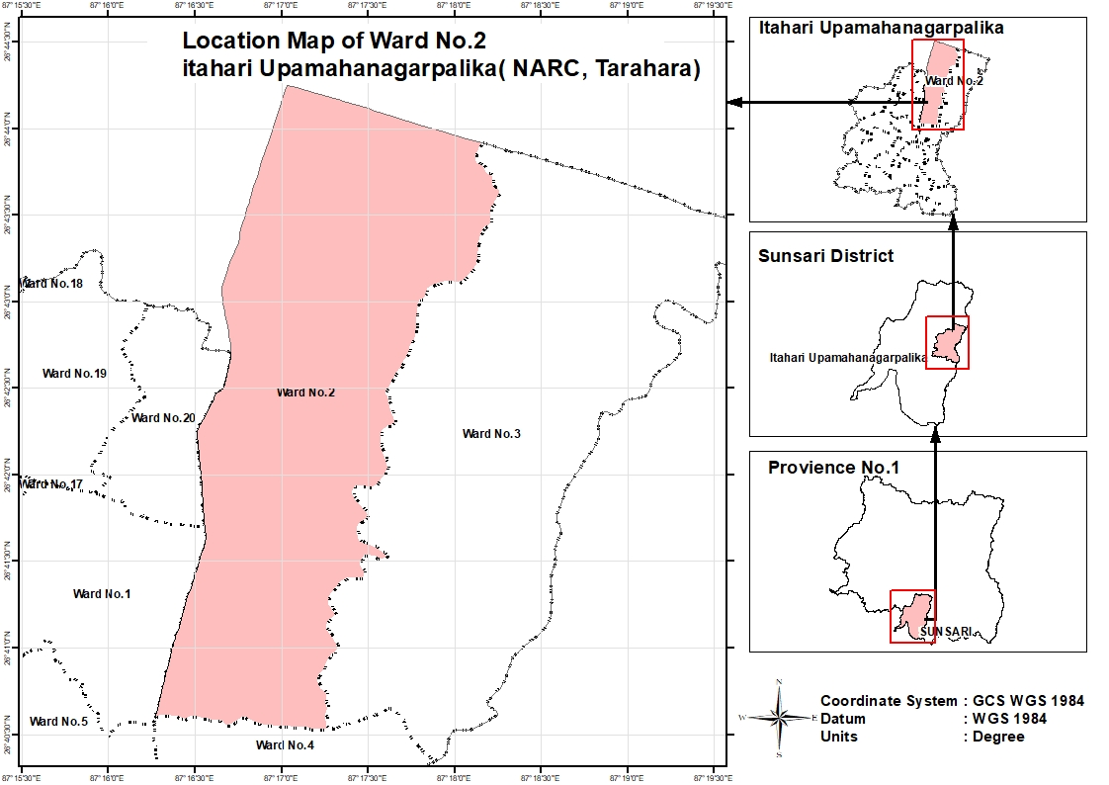

## 

## 

## 

Figure 3.2: Study area, NARC Tarahara.

## 3.2 Study Methodology

In this study we mainly focus on the comparative economic and analysis of various treatments used in wheat cultivation such as seeder, rotavator and zero-till seed cum fertilizer drill to compare the productivity and cost of production using these treatments. To carry out these studies following activities were performed in the selected three plots in the field of DoAR, NARC, Tarahara.

### 3.2.1 Plot Division

The study involves the comparison of produced yield from the field using three different treatments i.e. super seeder, Rotavator and zero-till seed cum fertilizer drill. Here, the entire field is divided into three plots of area. For each one plot different treatments were subjected for sowing the wheat.

### 3.2.2. Calibration for Treatment used

Calibration is the process of altering and setting the equipment's numerous characteristics and parts to make sure they are functioning accurately and effectively. By lowering the chance of over- or under-applying inputs, calibration enables the machinery to run as efficiently as possible, improving crop yields, cutting down on waste and costs, and enhancing operator safety. Regular calibration of these agricultural implements helps to ensure that the crops are dropped properly at optimum depth and adequate row spacing is always maintained between the crops. The calibration of the treatments subjected in this study are described as below:

#### 3.2.2.1. Calibration of zero till seed cum fertilizer drill

The method of calibration of ZT that we adopted in the field 4 is described below:

1. First of all, the diameter of transport wheel (d) in meter is measured to calculate the circumference of wheel

Circumference (C) = π *d

1. The effective width of the seed drill is then measured

Effective width (W) = N*S

Where, N = number of furrow opener

s = spacing between the opener

1. Calculate the area covered in one revolution of wheel

Area covered in one revolution = C * W

1. Calculate the number of revolutions required to cover 1 ha. areai.e. 10,000

R =

1. Raise the seed drill, so that the wheel for N turns and collect the seed under each tube on paper bags or cloth and measure the weight (K) of collected seed.

Calculate the seed weight of the number of revolutions required for one ha. area

Seed rate = Kg/ha

#### 3.2.2.2. Calibration of Super Seeder

First of all, fill the seed and fertilizer in the respective boxes. Set the indicator at desired seed and fertilizer rates. Mark a distance of 50 meters in the field Take the seed and fertilizer delivery pipes out from the boots and put delivery outlets of the pipes in the polyethene's bags and tight them using rubber rings. Run the machine and collect the seeds/fertilizers from each delivery pipe after a 50-meter run of the machine. The number of seed and fertilizer collected from each delivery pipe in a 50-meter run is then weighed in grams. Then we calculate the seed rate and fertilizer rate by the given formula:

1 ha. = 10,000

Width of planter = x (m)

Distance = 20 m

Weight of seed or fertilizer in pipes = y (kg)

Seed or fertilizer rate (kg/ acre) =

If the seed or fertilizer rates are not as per the desired rates, then reset the indicators or the inclined plates, gears etc. in accordance to the desired rates and the whole process of field calibration is repeated as described above (Mulvaney & Devkota, 2020a)

#### 3.2.3 Sowing of Wheat

The "BL4341" variety of wheat is sown in the field. The study's main goal is to compare the yields achieved by applying various treatments to each plot and conduct an economic analysis for each of these treatments. Three distinct fields with various treatments have been employed to sow the BL4341 variety of wheat. We assigned a number for each plot where wheat is sown using appropriate treatment.

Table 3.1 Sowing of Wheat

|  |  |  |
| --- | --- | --- |
| **Field Plot Number** | **Treatment used** | **Number of Sample Replication** |
| T 1 | Super Seeder | 10 |
| T 2 | Farmers Practices (Rotavator) | 10 |
| T 3 | Zero-Till | 10 |

In the plot 1 and plot 3 the treatment (i.e., Super Seeder and zero-till seed cum fertilizer drill) is operated directly into the field where there were standing stubbles of previously harvested paddy. A three-point connection system was used to attach these treatments to the tractor. The tractor's PTO shaft was connected to the machine's PTO shaft linkage, which powers the flail, after being hitched to the tractor. Seed and fertilizer begin to fall into the furrows and slits created by the furrow opener as the drive wheel drives the fertilizer and seed metering device. The flail begins to operate through the PTO shaft, and these revolving flails clean the debris that comes in front of the types.

#### 3.2.4 Area of plot

As the area of the study field is not perfectly rectangle, we measure the area of each plot using the measuring tape for the calculation.

## 3.3 Data collection

For the comparative study of economic analysis of various treatments used for seed establishment in wheat cultivation, various data are collected from both the primary source as well as secondary sources such as research articles, journals and books related to research topics.

### 3.3.1 Primary Data

Primary data of this study is collected directly by visiting fields, observation and survey. Primary data was collected from the time of sowing of wheat crops in the field using various treatments till the harvesting of fully ripened wheat. The data for analysis were collected before and during treatment operation in the field i.e. before operation of treatments the area of field is measure and during operation the time taken by each treatment to complete sowing in respective field using particular treatment, calibration of super seeder and zero-till seed cum fertilizer drill implement, horsepower of tractor used to pull these treatments in field, rate of discharge of water during irrigation in the field, various plant parameters such as plant height, spike length, number of plant per tiller, grain weight per meter square, grain moisture number of grain per spike and plant population in 1m*1m area for 10 numbers of replication on each treatment. Also after fully ripening of wheat crop the yield data of each plot (i.e T1, T2, and T3) was also collected.

The overall primary data collected is discussed in the following section:

#### 3.3.1.1. Area of plot

The area of all three plots is determined using the measuring tape. The area of each plot are as follow

Table 3.2 Area of plot

|  |  |  |
| --- | --- | --- |
| **Plot Name** | **Treatment used** | **Area ()** |
| T1 | Super Seeder | 2024.97 |
| T2 | Rotavator/Farmer's Practice | 2218.08 |
| T3 | Zero-Till | 1436.31 |

#### 3.3.1.2. Seed rate of the implement

The seed rate of the super seeder and ZT at which it drops both the seed and fertilizer was set at 118.34 kg/ha. This rate was set only after the calibration of both of these machines.

#### 3.3.1.3. Volume of irrigation of water applied in the field

A single irrigation in the field was sufficient to meet the crops water requirements of each plot. After 25 days of wheat seeding, the first irrigation was applied to the crop. By measuring the discharge and the time needed to finish the irrigation, the total volume of water applied for irrigating the field was estimated, and the water needs of each plot were compared and evaluated. A Rectangular weir was inserted into the canal where water flows from crest, the height of crest was measured from the ground surface which is termed as head and the other related measurement of the rectangular weir was measured and used for calculating discharge using the formula below:

The Volume was calculated by;

Volume (V) = Discharge (Q) * Time (T)

#### 3.3.1.4. Amount and Type of Fertilizer and Herbicide applied

The right type and dose of fertilizers at the right time such as DAP, urea, and potash help to ensure good yields of high-quality wheat. Basal fertilizer dose of DAP (Diammonium Phosphate), urea, and potash was applied in the field one day before sowing and after 30 days of sowing top dressing of only urea was done closely in the crop with an objective of supplying nitrogen in readily available form to growing wheat plants.

Table 3.3 Amount and Type of Fertilizer and Herbicide applied

|  |  |  |  |  |
| --- | --- | --- | --- | --- |
|  | | **Date of application** | **Dose Type** | **Dose** |
| **Fertilizer** | Basal Fertilizer Dose | 8th Dec, 2022 | DAP, Urea, Potash | (3kg, 3kg, 1.5kg) per kattha |
| Top Dressing | 8th jan,2023 | Urea | 3kg per Katha |
| **Herbicide** | Pre application | 8th Dec, 2022 | Pendimethalin, Glyphosate | 3.5 lt/ha  3 lt/ha |
| Post application |  | 2-4-D | 1.5 lt/ha |

#### 3.3.1.5. Sampling of crop plant

In this study we undertook a 1m*1m metal frame and randomly place it in the field and a sample of crop plant was taken from inside the frame only. During sampling we considered the border effect and took samples 2ft inside from all sides of the field. Also samples were taken without being biased but considering to cover the area with proper plant growth.

#### 3.3.1.6. Determination of plant parameter

The wheat crop reached full maturity and was ready for harvesting 129 days after it was sown. Various plant parameters were collected from each plot of the entire field prior to harvest using a combine harvester. Plant characteristics include plant height, spike length, number of plants per tiller and number of plants or plant population per meter square in each replication.

#### 3.3.1.7. Yield Measurement

For the yield measurement of all three-treatment employed on respective fields plot, ten replications of 1m*1m areas were selected randomly on each plot. A 1m*1m size steel frame was randomly placed in the field for each plot at ten different points (i.e. 10 replication for each plot) and the crop plants were harvested manually to measure yield and various plant parameters.

After harvesting the wheat crop it was then threshed manually by running the wheat heads under the feet to release the wheat berries. Alternatively, smacking the cut stalks against trapping on the ground. The wheat berries are then separated from the residue by simply putting the wheat berries on the blanket and gently tossing them into the air several times. The clean wheat berries obtained after winnowing is then weighted and yield from 1area is obtained which is later converted into the total area of plot. Similarly, the yield from other plots were measured and economic analysis of all four treatments was performed.

#### 3.3.1.8. Thousand Grain Weight

Thousand grain weight represents the weight of 1000 wheat grains and is an important measure of the yield potential and quality of grain crops. A higher 1000 grain weight of wheat is associated with a higher percentage of endosperm, which is the primary determinant of flour quality. Thus, higher the thousand grain weight the higher is the quality of wheat flour. The weight of the thousand grains was obtained by counting the thousand number of grains from each treatment manually and then measuring its weight and recording the measured data.

#### 3.3.1.9. Moisture Content Measurement

After threshing the wheat grain manually by running the wheat heads under the feet the grain was then cleaned. The cleaned grain was then put inside a digital moisture meter that gives the moisture percent of whole grains. It displays the moisture content of the grain in weight percent of each replication. The measured MC was then recorded and used for further analysis of the study (*STATISTICAL-INFORMATION-ON-NEPALESE-AGRICULTURE-2077-78*, n.d.-b)

#### 3.3.1.10. Adjusted Yield

Adjusted yield describes crop yield that has been modified to take into account variables like weather, disease outbreaks, and other elements that can have an impact on production. The process of calculating adjusted yield entails starting with the actual yield and making various adjustments to it. A more accurate picture of the true productivity of a crop or farm can be obtained by accounting for several elements in the yield. An essential part of handling and storing grains is bringing their moisture levels up to par. It enhances the wheat crop's efficiency, marketability, storability, and ability to maintain quality. The adjusted yield is calculated using the formula below (*Wheat Seed Production Techniques Manual*, n.d.)

Adjusted Yield =

#### 3.3.1.11. Gross Margin

After all activities, the total variable cost of production and total gross revenue were determined for calculating the study's gross margin. Gross Margin is an important indicator of profitability which was calculated by deducting the whole variable cost of production from the total revenue. Gross margin values can either be positive or negative. If the input or variable cost is more than the income, it is confirmed that the application of that technology is not advantageous. Positive gross margin shows that the application of specific treatments in the field was determined to be profitable. A low gross margin would suggest that the produced wheat grain is being sold at a lower profit, while a high gross margin suggests that the technology is able to generate and sell the wheat grain at a larger profit margin. The formula for calculating gross margin is given below:

Gross Margin = Total Revenue - Total Variable cost

#### 3.3.1.12. Benefit-Cost Ratio (B/C Ratio)

The B/C ratio of all the treatments employed in the field for wheat cultivation is then calculated by dividing the total benefit from the treatment used by the total cost of production. The benefit-cost ratio is commonly used in cost-benefit analysis, which is a technique used to evaluate the economic feasibility of a machinery in the field. A BCR greater than 1 indicates that the benefits of the project outweigh its costs, while a BCR less than 1 indicates that the costs outweigh the benefits. Therefore, the higher the BCR, the more attractive is the implementation of particular machinery in terms of financial perspective.

## 3.3.2. Secondary Data

Secondary data for this project were collected through research articles, journals and books, Literature, desktop review and NARC annual reports. The area coverage of the study site, latitude and longitude were obtained from Google Earth. Also, the data such as soil texture and soil pH were obtained from the annual report of NARC, Tarahara.

## 3.4. Data Analysis

The data obtained from both the primary and secondary source are then properly tabulated and recorded using Microsoft Excel. Tabulated data is then analyzed and calculations are made using various parameters such as comparison of yield produced by each treatment on each three respective plots, calculation of Gross margin, straw-grain ratio of each treatment and the adjusted yield.

# 

# 

# 

# Chapter 4: Results and Discussion

The Result and Discussion portion contains the findings from project site observation, measurement, computation, and comparison of various parameters of wheat crop.

## 4.1 Calibration of Treatments

In this study we employed three different treatments for sowing wheat in all three different plots in which are for plot 1 we use Super Seeder for sowing, for plot 2 we used Farmers Practices/Rotavator and for plot 3 we used Zero-Till Seed cum Fertilizer Drill machine. All of these treatments were pulled over the soil using a 75 HP tractor for rotavator and SS and 60 HP tractor for ZT. Before sowing wheat seed in the field using above mentioned machinery the seed and fertilizer application rate was set in the machine at 118.343 kg/ha as recommended by NARC and Department of Agricultural Division. This rate was set in ZT and SS by adjusting the lever which is responsible for dropping of seed and fertilizer at a certain rate into the soil.

### 4.1.21. Calibration of Super Seeder

The calibration procedure of Super Seeder is similar to that of Turbo Seeder. The calibration calculation is performed by obtaining following data:

Number of rows (N) = 10

Spacing between two rows (S) = 22 cm = 0.22 m

Width of sowing (B) = N*S = 10*0.22 = 2.2 m

Length (L) = 20 m

Area (A) = L*B = 20*2.2 = 44

Weight of seed or fertilizer sowed = 23.96 kg

Rate of seed or fertilizer calibration = = 118.343 kg/ha

### 4.1.2. Calibration of Zero-Till

Calibration of Zero-Till is done by measuring the following parameters of the machine.

Calculation

1. Diameter of transport wheel (d) = 42 cm = 0.42 m
2. Circumference (C) = π *d = π * 0.42 = 1.35 m
3. Effective width (W) = N*S = 9*0.2 = 1.8 m
4. Area covered in one revolution = C * W = 1.35*1.8 = 2.43 m
5. Number of revolutions required to cover 1 ha.

R = = 10000/2.43 = 4115

1. Weight (K) of collected seed in plastics for 10 revolution of wheel= 0.29 kg

1. Seed rate = Kg/ha = 118.343

## 

## 4.2. Comparative Analysis of Treatment

This section compares a range of treatment factors that are connected to yield, plant characteristics, input utilization, gross margin, straw-to-grain ratio, BCR. The field work was done in order to conduct a comparative economic study of the different wheat establishment techniques used in the field and to more thoroughly explore the cost implications.

### 4.2.1. Comparison of Wheat yield

For the calculation of wheat yield, we select various small areas on each plot in the field and measure the yield of each small replication and then calculate the total yield of the all three plots subjected to respective treatments and compare them. Various parameters such as number of plant population in selected 1m*1m area of each replication on the respective plots, number of tillers per plant and yield of wheat from 1m*1m replication area was properly recorded. The results and conclusions drawn from the results of those parameters are discussed below with their respective Annex.

#### 4.2.1.1. Wheat Yield in 1 area

For the yield calculation from selected 1area, a metal frame of 1m*1m was randomly placed at ten different points on each plot and the wheat crop that retained into the frame was manually harvested and then threshed. The ten replication for each treatment were given respective name such as for first plot with Super Seeder replication is denoted as SR1, SR2, SR3, SR4, SR5,......SR10 for Rotavator employed plot replication is denoted as RR1, RR2, RR3, RR4,....... RR10 similarly for Zero-Till field replication is denoted as ZR1, ZR2, ZR3, ZR4,........... ZR10. The average yield from randomly selected replication in all three plots was found to be 248.44 gm. (ZT), 342.69 gm. (SS), and 306.18 gm. (FP) respectively. From the above data the average yield from the Super Seeder used field was found higher in comparison to other two treatments. The sample yield of all 10 replications of all three treatments is given in Annex A.

#### 4.2.1.2. Total yield of entire field

After measuring the average yield from 1m*1m using respective treatment the total yield of the entire plot and yield per hectare is determined and presented as shown in table 1.

Table 4.1 Total yield of entire field.

|  |  |  |  |  |
| --- | --- | --- | --- | --- |
| **Plot** | **Area**  **()** | **Treatment used** | **Average yield in 1area (Kg)** | **Yield in 1 ha. Area (Kg/ha)** |
| 1 | 2024.97 | Super Seeder | 0.34269 | 3426.9 |
| 2 | 2218.08 | Farmer Practice (Check) | 0.30618 | 3061.8 |
| 3 | 1436.31 | Zero-Till Seed cum Fertilizer Drill | 0.24844 | 2484.4 |

Figure 4.1: Average Yield per m2.

The average wheat production in Sunsari district is 3250 kg per hectare (*Wheat Seed Production Techniques Manual*, n.d.). In the comparison of the data from table 4.1 with the yield data of sunsari district, the production of wheat was found to be higher from super seeder application. The yield is found higher in the Super Seeder method which is 3426.9 kg/ha followed by farmer’s practice (3061.8 kg/ha) and zero-till seed cum fertilizer drill (2484.4 kg/ha). The lower in the yield from plot 2, and 3 in comparison to plot 1 with super seeder method may be due to various factors such as non-uniform seed rate of treatments, soil moisture, soil texture, level of ground water table in the study area, method of sampling, over or under irrigation etc.

Figure 4.2: Total yield vs. plant population in Farmer’s practice field.

In the case of Farmer’s practice, the plant population is significantly higher as shown in the above graph, but the yield is noticeably lower than expected. So, we may conclude that the counting of crops that did not produce grain is the primary reason for the decreased yield in this approach.

Figure 4.3: Total yield vs. plant population in ZT field.

In the case of ZT, even though there are more plants counted, the yield is still poor. As a result, we can say that in majority of the replication, plants that were counted, did not contain grain which resulted in lower yield.

Figure 4.4: Total yield vs. plant population in SS field.

We can observe from the graph above that the yield and plant population are directly correlated. The super seeder yield was determined to be higher because, according to the graph between plant population and yield, all of the plants that were counted possessed grain and also may be due to the incorporation of biomass in the soil. Thus, the yield was found to be higher in comparison to ZT and FP methods.

#### 4.2.1.3. Straw yield

After the grain was threshed only straw remains, the average amount of straw yield from each treatment was found to be 0.33883 kg/, 0.31126 kg/ and 0.25695 kg/ respectively on each plot where super seeder, farmer’s practice and zero-till seed cum fertilizer drill was employed for wheat sowing. The amount of straw yield per hectare is as shown in table 2.

Table 4.2 Straw yield per ha.

|  |  |  |  |  |
| --- | --- | --- | --- | --- |
| **Plot** | **Treatment** | **Area ()** | **Straw yield**  **(kg per )** | **Straw yield per hectare (Kg/ha)** |
| 2 | Super Seeder | 2024.97 | 0.33883 | 3388.3 |
| 3 | Farmers Practices | 2218.08 | 0.31126 | 3112.6 |
| 4 | Zero-Till Seed cum Fertilizer Drill | 1436.31 | 0.25695 | 2569.5 |

## 

## 4.3. Number of plants per 1 (Total Plant Population)

The number of plants that retained inside the 1m*1m metal frame is then counted manually. The average plant population in each plot was found to be 331.6, 310 and 291.3 respectively in plot-1, 2, and 3. The average number of plants in the 1mx1m area of the super seeder plot was found more than the other two Plot. Data on the number of plants per square meter of each 10 replications are given in Annex B.

Table 4.3 Total Plant Population per .

|  |  |  |
| --- | --- | --- |
| **Plot** | **Treatments** | **Plant population per (No.)** |
| 1 | Super Seeder | 332 |
| 2 | Rotavator/ farmer practices | 310 |
| 3 | Zero-Till seed cum fertilizer drill | 291 |

Figure 4.5: Average plant population per meter square.

From the above table 4.3 and graph 4.4 we can conclude that the yield in the super seeder field is found to be higher as the plant population in this method is found higher. In terms of plant population in each sample replication, it was discovered that while having a higher plant population in some replications from each treatment, the yield was lower. This leads us to the conclusion that the reduced yield may be the result of counting the plants that are empty of grain.

## 4.4. Plant Height

The average height of the plant from all 10 replications was measured in each field plot before harvesting. The average height of the plant on the plot using a super seeder was found to be 95.9 cm, 95.4 cm on the plot with the rotavator (farmer’s practice) used, and 97.7 cm on the plot with the ZT used plot. The average height of the plant of each 10 samples in replication is given by the table in Annex C.

Table 4.4 Average Plant Height.

|  |  |
| --- | --- |
| **Treatment used** | **Average plant height (cm)** |
| Super seeder | 95.9 |
| Farmers practices | 95.4 |
| Zero-till seed cum fertilizer drill | 97.7 |

From the above treatment we can see that the plant height of the wheat crop was found to be high in the ZT used field plot in comparison to farmer’s practice and super seeder used plot. This can also be presented in graph as below:

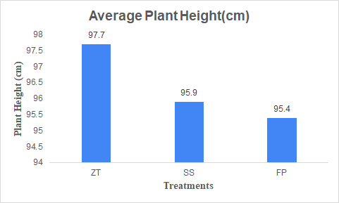

Figure 4.6: Average plant Height (cm).

The plant height of ZT is higher in comparison to other two treatments, which may be because of early germination of seed in the field where ZT is used for seed establishment. Also this field has higher capacity to retain moisture due to less soil manipulation or no-till.

## 4.5. Spike length

In this study we assess the spike length of the wheat crop using a measuring scale. With each plot undergoing a different treatment, 10 spike length samples were collected. The zero-till seed cum fertilizer drill produced the highest average spike length of 10.2m, which was followed by 9.8m from farmer’s practice and 9.7m from super seeders. The sample data for each treatment are shown in Annex D.

Table 4.5 Average Spike Length.

|  |  |
| --- | --- |
| **Treatment** | **Average Spike Length (cm)** |
| Super seeder | 9.7 |
| Farmers practices | 9.8 |
| Zero-till seed cum fertilizer drill | 10.2 |

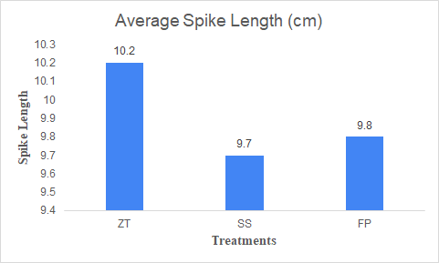

Figure 4.7: Average spike Length (cm).

The spike length in ZT practice is longer than in SS and FP, as shown in the above-mentioned graph and table. This difference may be attributable to timely sowing, suitable fertilization, and efficient weed control. Additionally, efficient control of pests and diseases that target the spike or inflorescence can help prevent damage and ensure long spike length.

## 4.6. Grain per spike

The number of grains in each spike was determined by counting each individual grain of wheat. From each field plot, 10 samples of grain were selected for this investigation, and the grains were manually counted. The field with the use of a zero-till seed cum fertilizer drill had the highest average number of grains per spike, 40, and was followed by a super seeder plot's 34.7 and a farmer's practice plot's 34. Annex E contains sample data on the amount of grain per spike for all 10 samples.

Table 4.6: Average Grain per spike.

|  |  |
| --- | --- |
| **Treatment** | **Average grain per spike in 1** |
| Super seeder | 34.7 |
| Farmers practices | 34 |
| Zero-till seed cum fertilizer drill | 40 |

Figure 4.8: Average Grain per spike.

As evidenced by the table and graph above, there are more grains per spike in FP. The optimal plant density in FP enables each plant to have adequate access to sunlight, nutrients, and water, improving grain development and increasing the amount of grains per spike.

## 4.7. Thousand grain weight

The thousand grain weight is calculated by counting thousand wheat grain and measuring its weight and the obtained weight is as follows:

Table 4.7 Thousand grain weight.

|  |  |
| --- | --- |
| **Treatment** | **Thousand grain weight (kg)** |
| Super Seeder | 0.02978 |
| Farmers Practice (check) | 0.02904 |
| Zero-Till Seed cum Fertilizer Drill | 0.02132 |

Figure 4.9: Thousand Grain weight.

From above table 4.7 and graph 4.8 the thousand grain weight from super seeder (0.02978 kg) is found greater and thus we can say that the flour quality of wheat from this method will be of higher quality than the other two methods.

## 4.8. Number of tillers per plant

A tiller is a sprout that emerges from the plant's base and bears leaves, stalks, and occasionally flowers. A plant's prospective output may be significantly influenced by the quantity of tillers it generates. In this study the number of tillers per plant is counted manually and the obtained data was recorded. The average number of tillers per plant data is as given in table 4.7 below:

Table 4.8 Average Number of tillers hill.

|  |  |
| --- | --- |
| **Treatment** | **Average number of tillers per plant** |
| Super Seeder | 9.3 |
| Farmers Practice | 7.5 |
| Zero-Till Seed cum Fertilizer Drill | 8.9 |

The data of all replication on the number of tillers per plant of respective treatment is given in Annex F.

Figure 4.10: Average number of tillers per hill.

## 4.9. Comparison of Volume of water required for irrigation

To fulfill the water requirement of wheat, crop the field was irrigated after 25 days of sowing. The water requirement of the field crop was encountered with single irrigation. The discharge rate of irrigation water was measured using a rectangular notch. The volume of water required for irrigation using rectangular notch were recorded and used in the calculation of discharge rates using the formula given below ( Vlab):

Where,

Q = Discharge in lt/sec

Ce = function of H/P or L/B

L = Length of weir in meter

Kb = function of L/B

H = Head on the weir

## 

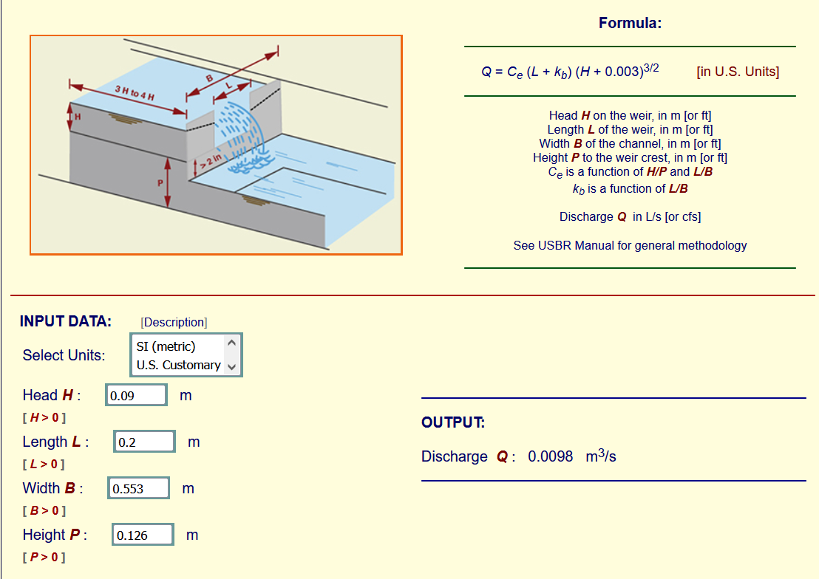

Figure 4.11: Comparison of Volume of water required for irrigation.

(Source: Vlab Online_rectangular_weir)

The crop water requirement was fulfilled with single irrigation only; this may be due to various causes such as high soil moisture content, high ground water table etc. We can state that field crop water requirement of plot 3 where zero till seed cum fertilizer was employed has lower water requirement as compared to farmer’s practice of wheat sowing followed by super seeder. The following is a discussion of some of the causes.

* Because of the tillage operation in the traditional plot, the soil surface slows down water's gravity flow, causing irrigation water to move more slowly, infiltrate more water, and lose more water.
* Because the zero-till method uses conservation tillage and doesn't till the entire plot, irrigation water moves through the zero-till plot more quickly than it does in super-seeder and conventional plots.

Due to the compacted soil, there is less infiltration in the zero-till plot than in the conventional and super seeder used plots. In comparison to conventional plots, the zero-till seed cum fertilizer drill, and super-seeder plot has a higher irrigation water use efficiency. The time and the amount of water required for irrigating the entire field is saved when employing super seeder and zero-till seed cum fertilizer drill for sowing purposes. This method of sowing wheat crops is found more advantageous in areas with limited water supplies.

Table 4.9 Comparison of Volume of water required for irrigation.

|  |  |  |  |  |  |
| --- | --- | --- | --- | --- | --- |
| **Treatment** | **Discharge rate (** | **Time taken to irrigate (second)** | **Area ()** | **Volume of water required for irrigation ()** | **Depth of irrigation (cm)** |
| **Super Seeder** | 0.0098 | 7200 | 2024.97 | 70.56 | 3.48 |
| **Farmers Practices**  **(check)** | 25200 | 2218.08 | 246.96 | 11.1 |
| **Zero-till seed cum fertilizer drill** | 5400 | 1436.31 | 52.92 | 3.68 |

The depth of irrigation in the farmer's practice approach is higher, as can be seen from the above table, as this method involves using a rotavator three times throughout the entire field to appropriately move the soil and thus allow water to reach a specific depth. Therefore, the deeper irrigation depth in this approach is partially responsible for the increased yield.

## 4.10. Moisture Content of grain

When storing grains after harvest, grain moisture content is an important factor to take into account. The ideal moisture content needed to store wheat grain is 12 % (Mulvaney & Devkota, 2020b). In order to get the appropriate moisture for storage over a longer length of time, the drying process reduces the moisture content of grains, which is typically high during harvest time. In this study, we found moisture contents range in between 12% to 13.42%. The average moisture content of all three treatments was found to be 13.42%, 12.81% and 12.56%, respectively, in the plot where wheat was sown using a super seeder, rotavator or farmers practices, and zero-till seed cum fertilizer drill.

Table 4.10: Moisture Content of grain.

|  |  |
| --- | --- |
| **Treatments used** | **Moisture content (%)** |
| Super Seeder | 13.42 |
| Farmers Practices | 12.81 |
| Zero-till seed cum fertilizer drill | 12.56 |

Figure 4.12: Average Moisture Content of grain.

From the above table and graph we can say that the moisture content of wheat crop is higher from the plot where super seeder is used for wheat sowing followed by farmers practice and ZT. As the field soil has greater capacity to hold moisture and water in the field where super seeder was employed, thus wheat grain has a higher moisture content. As a result, the crop plant receives the necessary amount of hydration throughout the crop time. Sample data on moisture content of grain of each replication is given in Annex G.

## 4.11. Straw to grain ratio

The amount of straw to grain in wheat is greatly influenced by the wheat variety, the environment, and management techniques. In general, there should be 1.2 to 1.5 tonnes (1200 to 1500 kg) of straw produced for every tone (1000 kg) of grain produced in a wheat crop. This ratio is known as the straw-to-grain ratio. While crops with a low straw-to-grain ratio might be better suited for grain production alone, whereas those with a high straw-to-grain ratio can provide more crop residue for soil conservation, animal feed, or bio-energy production. The straw to grain ratio is calculated in this study by dividing the total straw weight by the grain weight.

Table 4.11: Straw-to-grain ratio.

|  |  |  |  |  |
| --- | --- | --- | --- | --- |
| **Plot** | **Treatment** | **Total grain yield**  **(Kg/ha)** | **Total straw yield (Kg/ha)** | **Straw to grain ratio** |
| 1 | Super seeder | 3426.9 | 3388.3 | 0.98 |
| 2 | Farmers practices | 3061.8 | 3112.6 | 1.02 |
| 3 | Zero-Till seed cum fertilizer drill | 2484.4 | 2569.5 | 1.03 |

Figure 4.13: Average Straw-to-grain ratio.

In the above table and graph we can see that the straw to grain ratio of FP and ZT is found greater than 1 which indicates that the obtained straw and grain are equal in quantity. Whereas in case of super seeder the straw to grain ratio is less than 1 which indicates that either the straw or grain yield is higher and from the above table we can see that the grain yield is higher than the straw yield.

## 4.12. Adjusted yield

Adjusted yield describes crop yield that has been modified to take into account variables like weather, disease outbreaks, and other elements that can have an impact on production. The process of calculating adjusted yield entails starting with the actual yield and making various adjustments to it. A more accurate picture of the true productivity of a crop or farm can be obtained by accounting for several elements in the yield. An essential part of handling and storing grains is bringing their moisture levels up to par. It enhances the wheat crop's efficiency, marketability, storability, and ability to maintain quality. The adjusted yield is calculated using the formula below (Mulvaney & Devkota, 2020c)

Table 4.12 Adjusted yield.

|  |  |  |  |  |
| --- | --- | --- | --- | --- |
| **Treatment** | **Total yield (Kg/ha)** | **Harvested moisture (%)** | **Adjusted yield at 12 % MC(Kg/ha)** | **Adjusted yield at 14% MC (Kg/ha)** |
| Super Seeder | 3426.9 | 13.42 | 3371.60 | 3450.01 |
| Farmers Practices | 3061.8 | 12.81 | 3033.62 | 3104.17 |
| Zero-Till Seed cum Fertilizer Drill | 2484.4 | 12.56 | 2468.59 | 2525.99 |

From the above table, the adjusted yield (Kg/ha) is higher in super seeder followed by farmers practice and zero-till seed cum fertilizer drill

## 4.13. Gross Margin

In this study, the gross margin of each treatment was calculated by deducting the total variable cost of production with the total revenue from the field. We measured variable costs under different heads such as :

Table 4.13 Gross Margin

|  |  |  |  |
| --- | --- | --- | --- |
| **Particulars** | **Super Seeder** | **Zero-Till seed cum fertilizer drill** | **Farmers practice**  **(Check)** |
| **Revenue:** | | | |
| Grain yield at 14% MC (Kg/ha) | 3450.01 | 2525.99 | 3104.17 |
| Straw yield (kg/ha) | 3388.3 | 2569.5 | 3112.6 |
| Return from Grain (Rs/ha) | 120750.35 | 88409.65 | 108645.95 |
| Return from straw (Rs/ha) | 10164.9 | 7708.5 | 9337.8 |
| **Total Revenue:** | **130915.25** | **96118.15** | **117983.75** |
| **Variable Cost:** | | | |
| Sowing machine hire cost(Rs/ha)   * Operator charge | 4577 | 4077 | 13500 |
| Labor for seed and fertilizer Sowing (Rs/ha) | 577 | 577 | 1731 |
| **Land preparation cost** | **5154** | **4654** | **15231** |
| Seed Cost (Rs/ha) | 9000 | 9000 | 9000 |
| Fertilizers Cost (Rs/ha) | | | |
| DAP (Rs/ha) | 3967.438 | 3967.438 | 3967.438 |
| Urea (Rs/ha) | 929 | 929 | 929 |
| Potash (Rs/ha) | 1451.193 | 1451.193 | 1451.193 |
| **Total Fertilizers Cost (Rs/ha)** | **6347.63** | **6347.63** | **6347.63** |
| Herbicide cost (Rs/ha) | | | |
| Pendymethyline | 2520 | 2520 | 2520 |
| 2-4-D | 1170 | 1170 | 1170 |
| Glyphosate | 0 | 2700 | 0 |
| **Total herbicide cost (Rs/ha)** | **3690** | **6390** | **3690** |
| Labor cost for fertilizer application (Rs/ha) | 1154 | 1154 | 1154 |
| Labor cost for herbicide application (Rs/ha) | 1154 | 1154 | 1154 |
| Labor for irrigation Cost (Rs/ha) | 577 | 577 | 577 |
| **Total labor cost** | **2885** | **2885** | **2885** |
| Irrigation Tariff (Rs/ha) | **2367** | **2367** | **2367** |
| Harvesting machine hire cost (Rs/ha) | 11000 | 11000 | 11000 |
| **Total variable cost** | **40443.63** | **42643.63** | **50520.63** |
| **Gross margin (Revenue-Variable cost)** | **90471.62** | **53474.52** | **67463.12** |
| **Gross Margin Rank** | **I** | **III** | **II** |

|  |  |
| --- | --- |
| **Price rate:** | |
| **Item** | **Rate** |
| Farm gate price of wheat grain (Rs/kg) | 35.0 |
| Farm gate price of straw (Rs/kg) | 3.00 |
| Labor Rate/day  Skilled Labor  Unskilled Labor | 750.00  577.00 |
| Seed price (Rs/Kg) | 75 |
| DAP price (Rs/Kg) | 44.7 |
| Urea price (Rs/Kg) | 15.7 |
| Potash price (Rs/Kg) | 32.7 |

From the above calculation it is found that the farmer’s practice approach is an economically beneficial method for sowing the wheat crop as the net benefit of this method is higher as compared to other two methods.

## 4.14. Benefit Cost Ratio (BCR)

After calculating the net benefits of each method, the BCR value is also calculated by dividing the net benefit value by the total cost of production. The BCR value of all three method is as shown in table:

Table 4.14: Benefit Cost Ratio (BCR).

|  |  |  |  |
| --- | --- | --- | --- |
| **Treatment** | **Net Benefit Value** | **Total cost of Production** | **BCR Value** |
| **Super Seeder** | 90471.62 | 40443.63 | 2.24 |
| **Zero-Till Seed cum Fertilizer Drill** | 53474.52 | 42643.63 | 1.25 |
| **Farmers Practices (check)** | 67463.12 | 50520.65 | 1.34 |

The BCR value of Super Seeder and Zero-Till Seed cum Fertilizer Drill and farmer's practice is greater than 1 which indicates that these methods are beneficial and outweigh its costs, while a BCR value of Farmers Practice is less than SS. Therefore, the implementation of Super Seeder is found attractive in terms of financial perspective. Furthermore, super seeder is more beneficial than FP.

# 

# 

# 

# 

# Chapter 5: Conclusion and Recommendation

## 5.1. Conclusion

When compared to Farmer's Practice, Zero-Till Seed Cum Fertilizer Drill, and the Super Seeder revealed a definite advantage. From the above-mentioned result, it can be shown that the yield of wheat per hectare using the Super Seeder is 11.14% higher than the farmer's practice, whereas the yield using the Zero-Till Seed cum Fertilizer Drill method is 18.63% lower than the farmer’s practice. Crop plants grown using a Super Seeder had better averages for tillers per plant, grain weight per thousand, grains per spike, and plants per square meter. The plant height is found higher in Zero-Till Seed cum Fertilizer Drill used field crop. Additionally, Super Seeder reduced the cost of production by Rs. 1059 per hectare, or 2.78%, compared to Farmer's Practice. Similar to this, the cost of production in the Zero-Till Seed cum Fertilizer Drill technique increased by Rs. 1141 per hectare, which was 2.83% more than the Farmers Practice Method. In the production of wheat, the Super Seeder was shown to be more profitable than Farmer's Practice, as evidenced by the Super Seeder's Benefit-Cost Ratio of 2.44. The Benefit-Cost Ratio for Zero-Till Seed cum Fertilizer Drill was found to be 1.39, which is greater than Farmer's Practice (0.2), indicating that it is more profitable to use the Zero-Till Seed cum Fertilizer Drill than the Farmer's Practice method. As a result, it can be said that the establishment of wheat using a Super Seeder and a Zero-Till Seed cum Fertilizer Drill is more profitable and effective than utilizing the Farmer's Practice approach. When comparing the Benefit-Cost Ratio of each method, Zero-Till Seed cum Fertilizer Drill is more profitable than Farmer's Practice.

## 5.2. Recommendation

Some areas are still to be improvised for better results of upcoming projects even after the completion of this project. Some recommendation from this study are as follows

* As this experiment was performed in NARC field and the obtained result was found beneficial and supports the use of super seeder thus it is recommended to perform this same experiment in farmer’s field which will also help in extension work
* Additionally, the Super Seeder contributes to an increase in the biomass content of the soil by sowing seeds on standing stubbles of paddy crops that remain on the ground, helping to preserve soil moisture and temperature while enhancing soil health. So, farmers are recommended to perform the test such as soil fertility, soil texture, and biomass content of soil in their field.

However, it is important to acknowledge the limitations of this study, such as soil parameters, impact of ground water table and harvesting losses. Despite these limitations, we believe that the findings of this project have important implications for local farmers.

# 

# 

# References

Ali, M., Ullah, Z., Saeed, M., Zubair, A., Ahmed, A., & Ahmad, B. (2021). Impact of Irrigation on Yield Attributes of Seven Wheat Genotypes. *Bangladesh Journal of Botany*, *50*(2), 235–243. https://doi.org/10.3329/bjb.v50i2.54078

*Annual Report*. (2073). http://www.narc.gov.np

Dhruba Thapa. (2021, November). Wheat In Nepal: A Look Back, And Ahead. *BGRI BLOG*.

Gautam, A., & Aulakh, G. S. (2022). Impact of Sowing Technologies of Wheat Cultivation in Ferozepur, Punjab. *Indian Journal of Extension Education*, 173–175. https://doi.org/10.48165/IJEE.2022.58436

*Grain Moisture Meter*. (n.d.). Laboratory Trade Concern.

JIquan Peng, Zihao Zhao, & Dinging Liu. (2022). Impact of Agricultural Mechanization on Agricultural Production, Income, and Mechanism. *Froniers*.

Mulvaney, M. J., & Devkota, P. J. (2020a). Adjusting Crop Yield to a Standard Moisture Content. *EDIS*, *2020*(3). https://doi.org/10.32473/edis-ag442-2020

Rajesh Murumkar, Usha Ramchandra Dongarwar, D S Phad, & Prashant S Pisalkar. (2015). Assessment of seed cum fertilizer drill for wheat sowing after paddy harvesting. *Research Gate*.

Samaya Gairhe, Tika Karki, Namdev Upadhyay, & Sudha Sapkota. (2019). Trend analysis of wheat area, production and productivity in Nepal: An overview. *Research Gate*.

Sana Ullah Baloch, LIU Li-jun, Muhammad Nawaz Kandhro, & Shah Fahad. (2014). Effect of Different Irrigation Schedules on The Growth and Yield Performance of Wheat (Triticum aestivum L.) Varieties Assessment in District Awaran (Balochistan). *Research Gate*.

Shreemat Shrestha. (2022). An overview of agricultural mechanization in Nepal. *Research Gate*, *16*(2).

*STATISTICAL-INFORMATION-ON-NEPALESE-AGRICULTURE-2077-78*. (n.d.-a).

*Wheat Seed Production Techniques Manual*. (n.d.).

# 

# 

# ANNEX

ANNEX A: One-meter square grain weight (gm.)

|  |  |  |  |
| --- | --- | --- | --- |
| **Treatment ➡**  **Replications ⬇** | **Zero-Till Seed cum Fertilizer Drill** | **Super Seeder** | **Farmers Practice** |
| 1 | 268.2 | 293.2 | 267.1 |
| 2 | 398.1 | 461.2 | 278.1 |
| 3 | 303.1 | 359.7 | 357.6 |
| 4 | 180.7 | 236.9 | 285.6 |
| 5 | 251 | 322.4 | 391.8 |
| 6 | 197.1 | 317.1 | 346.6 |
| 7 | 192.4 | 389.7 | 291.9 |
| 8 | 102.8 | 335.5 | 271.2 |
| 9 | 343.3 | 368.3 | 227.6 |
| 10 | 247.7 | 342.9 | 344.3 |
| **Average** | **248.44** | **342.69** | **306.18** |

Annex B: Number of plant per

|  |  |  |  |
| --- | --- | --- | --- |
| **Treatment ➡**  **Replication ⬇** | **Zero-Till Seed cum Fertilizer Drill** | **Super Seeder** | **Farmers Practice** |
| 1 | 377 | 371 | 244 |
| 2 | 335 | 396 | 325 |
| 3 | 300 | 336 | 355 |
| 4 | 240 | 263 | 262 |
| 5 | 306 | 350 | 310 |
| 6 | 307 | 329 | 278 |
| 7 | 285 | 215 | 360 |
| 8 | 183 | 325 | 297 |
| 9 | 304 | 356 | 351 |
| 10 | 276 | 375 | 318 |
| **Average** | **291.3** | **331.6** | **310** |

Annex C: Plant Height (cm)

|  |  |  |  |
| --- | --- | --- | --- |
| **Treatment ➡**  **Replication ⬇** | **Zero-Till Seed cum Fertilizer Drill** | **Super Seeder** | **Farmers Practice** |
| 1 | 90 | 87 | 102 |
| 2 | 89 | 96 | 103 |
| 3 | 97 | 99 | 97 |
| 4 | 105 | 101 | 97 |
| 5 | 95 | 96 | 101 |
| 6 | 100 | 101 | 90 |
| 7 | 102 | 90 | 98 |
| 8 | 105 | 95 | 84 |
| 9 | 106 | 92 | 91 |
| 10 | 88 | 102 | 91 |
| **Average** | **97.7** | **95.9** | **95.4** |

Annex D: Spike Length (cm)

|  |  |  |  |
| --- | --- | --- | --- |
| **Treatment ➡**  **Replication ⬇** | **Zero-Till Seed cum Fertilizer Drill** | **Super Seeder** | **Farmers Practice** |
| 1 | 10 | 11 | 11 |
| 2 | 9 | 10 | 9 |
| 3 | 9 | 8 | 11 |
| 4 | 10 | 9 | 9 |
| 5 | 9 | 8 | 10 |
| 6 | 10 | 9 | 10 |
| 7 | 11 | 12 | 10 |
| 8 | 9 | 10 | 9 |
| 9 | 14 | 9 | 8 |
| 10 | 11 | 11 | 11 |
| **Average** | **10.2** | **9.7** | **9.8** |

Annex E: Number of Grain per Spike

|  |  |  |  |
| --- | --- | --- | --- |
| **Treatment ➡**  **Replication ⬇** | **Zero-Till Seed cum Fertilizer Drill** | **Super Seeder** | **Farmers Practice** |
| 1 | 46 | 31 | 54 |
| 2 | 45 | 45 | 41 |
| 3 | 55 | 24 | 56 |
| 4 | 37 | 36 | 43 |
| 5 | 35 | 43 | 48 |
| 6 | 39 | 43 | 38 |
| 7 | 46 | 58 | 44 |
| 8 | 31 | 43 | 26 |
| 9 | 39 | 29 | 39 |
| 10 | 48 | 33 | 46 |
| **Average** | **42.1** | **38.5** | **43.5** |

Annex F: Number of tillers per plant

|  |  |  |  |
| --- | --- | --- | --- |
| **Treatment ➡**  **Replication ⬇** | **Zero-Till Seed cum Fertilizer Drill** | **Super Seeder** | **Farmers Practice** |
| 1 | 6 | 6 | 7 |
| 2 | 9 | 7 | 5 |
| 3 | 7 | 13 | 8 |
| 4 | 12 | 10 | 5 |
| 5 | 14 | 5 | 4 |
| 6 | 6 | 9 | 12 |
| 7 | 9 | 15 | 8 |
| 8 | 8 | 8 | 9 |
| 9 | 10 | 11 | 8 |
| 10 | 8 | 8 | 9 |
| **Average** | **8.9** | **9.2** | **7.5** |

Annex G: Moisture content of grain (%)

|  |  |  |  |
| --- | --- | --- | --- |
| **Treatment ➡**  **Replication ⬇** | **Zero-Till Seed cum Fertilizer Drill** | **Super Seeder** | **Farmers Practice** |
| 1 | 12.3 | 13.4 | 12.5 |
| 2 | 12.8 | 13.7 | 12.5 |
| 3 | 12.8 | 13.5 | 13 |
| 4 | 12.8 | 13.5 | 12.1 |
| 5 | 12.9 | 12.9 | 12.9 |
| 6 | 12.5 | 13.6 | 13 |
| 7 | 12.3 | 13.5 | 13.5 |
| 8 | 12.4 | 13.7 | 12.5 |
| 9 | 12 | 13 | 13.3 |
| 10 | 12.8 | 13.4 | 12.8 |
| **Average** | **12.56** | **13.42** | **12.81** |

Annex H: One-meter square Sample weight (gm.)

|  |  |  |  |
| --- | --- | --- | --- |
| **Treatment ➡**  **Replication ⬇** | **Zero-Till Seed cum Fertilizer Drill** | **Super Seeder** | **Farmers Practice** |
| 1 | 561.9 | 635.9 | 521.9 |
| 2 | 739.5 | 931.3 | 595.1 |
| 3 | 546.3 | 743.3 | 712.4 |
| 4 | 392.5 | 496.8 | 572.2 |
| 5 | 518.1 | 683.4 | 815.1 |
| 6 | 440.8 | 645 | 699.5 |
| 7 | 419.9 | 747.2 | 611.7 |
| 8 | 242.8 | 617.6 | 482.1 |
| 9 | 673.9 | 623.2 | 536.2 |
| 10 | 518.2 | 691.5 | 628.2 |
| **Average** | **505.39** | **681.52** | **617.44** |

Annex I: Picture of Activities

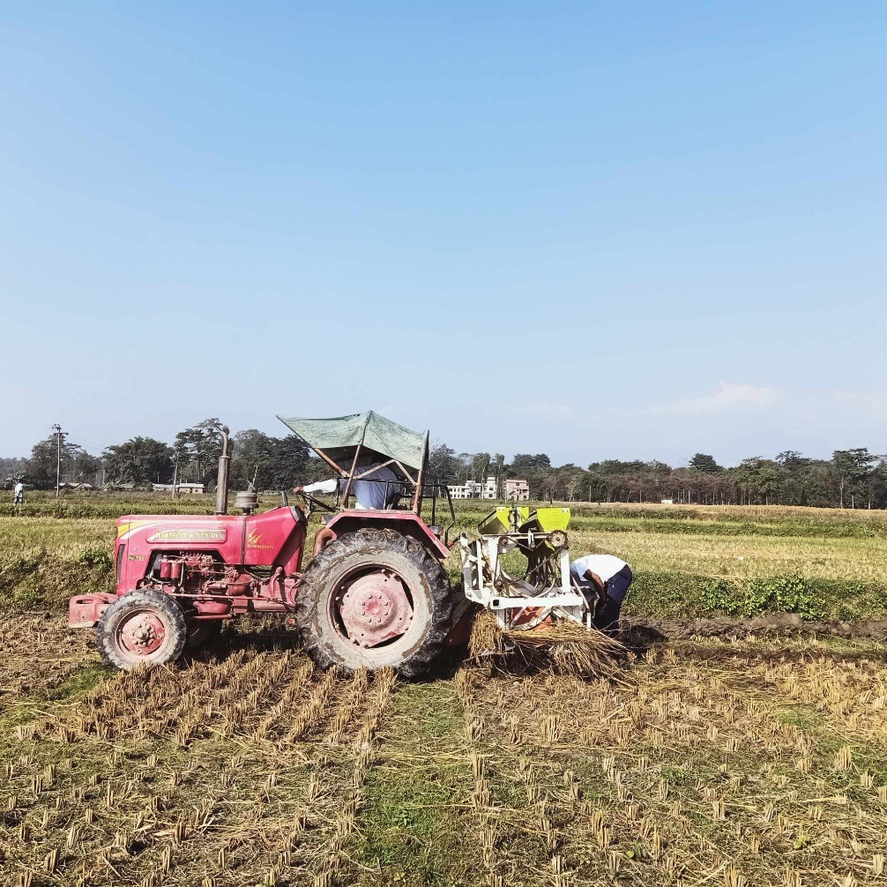

Figure: Sowing Phase

x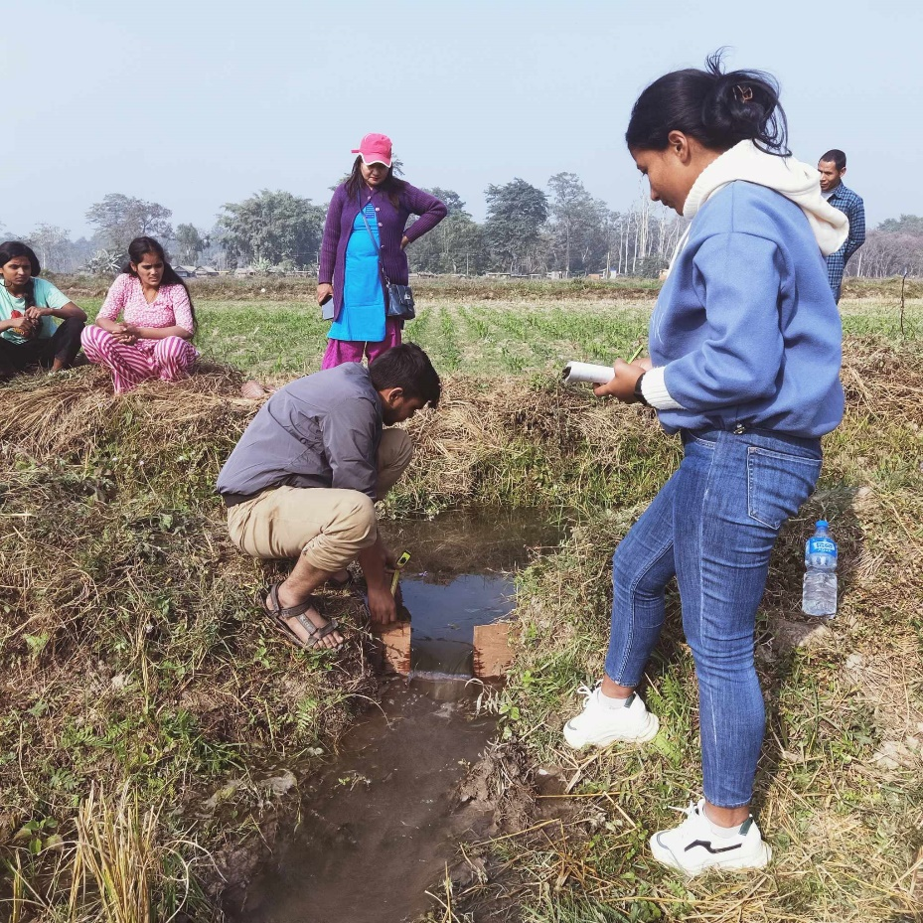

Fig: Irrigation Phase

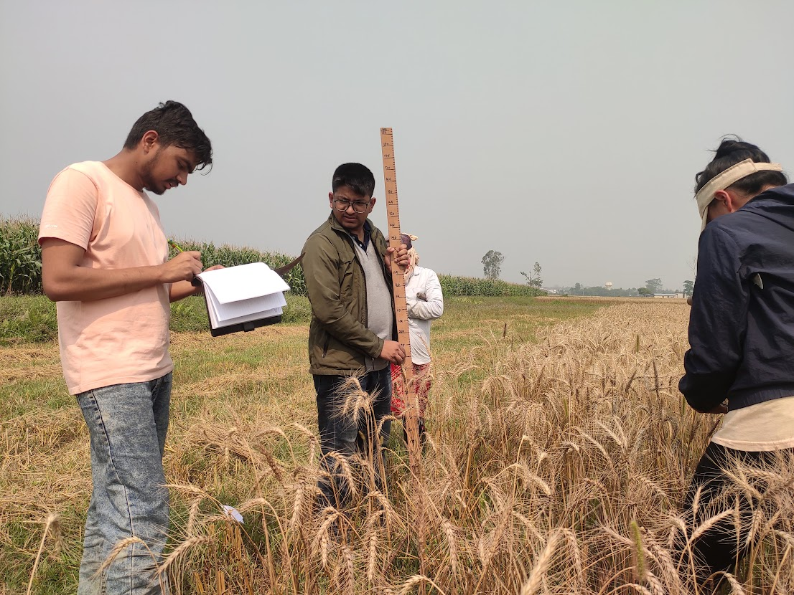

Fig: Data Collection Phase

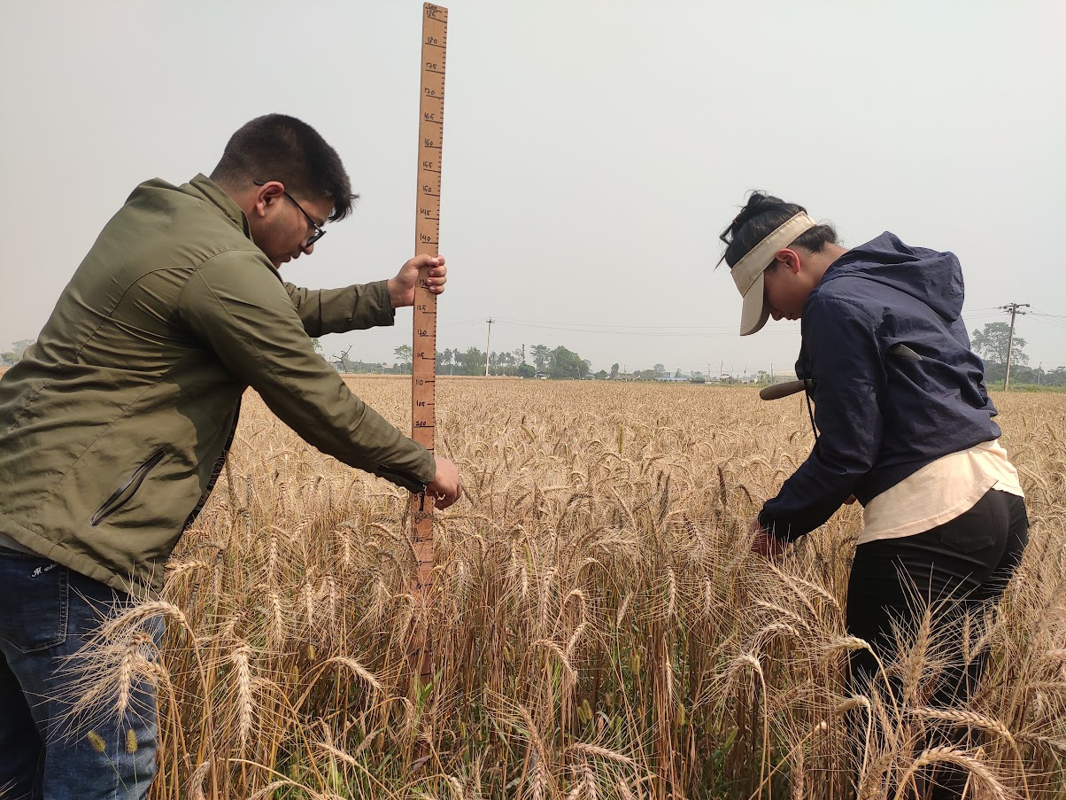

Fig: Data Collection Phase